|  |  |  |
| --- | --- | --- |
| **AFRICAN UNION** | Description: logo | **UNION AFRICAINE** |
|  | **UNIÃO AFRICANA** |
| Addis Ababa, Ethiopia P. O. Box 3243 Telephone: +251 11 551 7700 / +251 11 518 25 58/ Ext 2558  **Web site: www. au.int** | | |

**DIRECTORATE OF INFORMATION AND COMMUNICATION**

**Press Release**

**Pan African Institute for Education for Development (IPED) Holds a Strategic Planning Workshop**

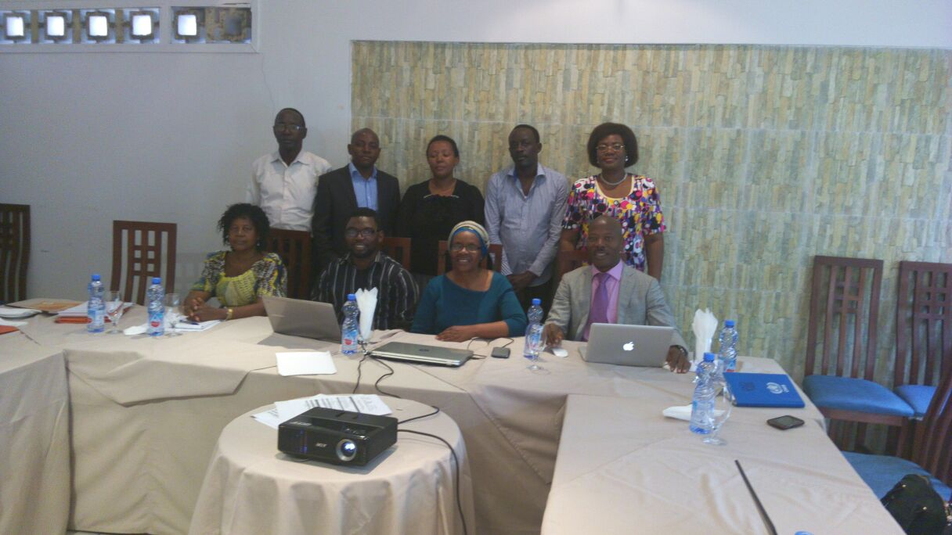**Kinshasa, Congo Democractic Republic- 26 October 2016-** The Pan African Institute for Education for Development (IPED) held a workshop to develop its strategic plan for 2017-2021 in Kinshasa from 26th to 28th October 2016. As the Education Observatory for the African union, IPED is responsible for ensuring that education development under the Continental Education Strategy for Africa (CESA 16-25), will be based on sound information and statistics to enable the education sector play its key role in ensuring production of the skills, knowledge and competences required to achieve Agenda 2063- the Africa We want.

The Strategic Planning exercise is part of the institutional revitalization efforts embarked upon by the Human Resource Science and Technology Department to ensure that the institution is fully operational and able to deliver on its mandate. The institution is responsible maintaining the continental Education Management Information Systems which houses all education related data submitted by Member States.

In her opening remarks, Dr Beatrice Njenga, Head of Education Division, reiterated the importance of IPED as the Education Observatory for the African Union saying that, considering the central role that education and training must play in ensuring the attainment of the goals of Africa’s Agenda 2063, it goes without saying that the Observatory will be key in assuring the adequacy, responsiveness and quality of education in meeting these demands. She said that the Continental Education Strategy for Africa therefore lays special emphasis on the need to establish a robust platform for education planning, coordination, monitoring and reporting. The Observatory is key in enabling Africa to take charge of its own data and information; and ensure evidence based planning anchored in a robust continental EMIS. She concluded that the Education Observatory role is beyond management of information and training of field officers, and includes policy analysis as well as strategic research to inform decision making in education development on the continent. The workshop was facilitated by Mr Lukman Jaji, IPED’s new ICT Officer, who explained that the Observatory had already developed some key software for enhancing the efficacy of data collection in Member States.

The workshop was supported by the African Observatory for Science Technology and Innovation (AOSTI) and the African Union Representational Office in Kinshasa, Congo.

Further media inquiries should be directed to:

Mr. Lukman Jaji | Policy Officer, ICT & Documentation | Human Resource Science and Technology Department | African Union Commission | Tel: (251) 11 551 77 00 | Fax: (251) 11 551 78 44 | E-mail: jajiL@africa-union.org | Web: www.au.int | Addis Ababa | Ethiopia

Follow us

Face book: https://www.facebook.com/AfricanUnionCommission

Twitter: https://twitter.com/_AfricanUnion

YouTube: https://www.youtube.com/AUCommission

Learn more at: http://www.au.int